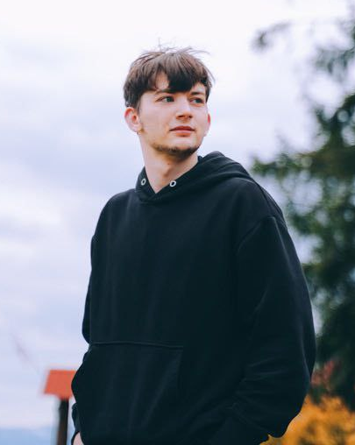
My name is Ivan Lipovoy, I am 19, and I am from Vesele, Zaporizhzhia region. Our village is occupied by Russians now. I was born into a non-Christian family, neither my mom nor my dad or stepfather ever visited church.
Before I was 14, I hadn’t known about the existence of a church in our village, and I wasn’t even interested in it. But there was one boy in my class who visited church, and one day he invited me to go to church with him. With time, I started understanding true Christianity. I was doing everything that the pastor asked us to do, and I was the best in my group. I started reading the Bible and trying to live according to it. Soon, it became a part of my life.
There were times when I was hesitant. I even wanted to stop visiting church under the influence of friends and society. But my experience with God stopped me from making such a mistake. I decided that I wanted to stay with God and allow Him to rule over my life. My parents never forbade me to go to church, but sometimes they didn’t understand my actions and didn’t support me. Now, they fully support me.
I gave my heart to Jesus at a Christian camp. I found out something new about God each day. I was filled with His presence, and it drew me closer to Him. Furthermore, I was baptized with the Holy Spirit right there in the camp after inviting Jesus into my heart. I am still in the process of growing in my relationship with God. I feel that I know very little about Him and His word. I need to know more. I also need to change my character as I follow Jesus.
My very first ministry at church was very simple: I helped my pastor fix the church building. I was always very glad to help him. When we started having children's camps, I wanted to help there too. It was so important for me to be able to help in the same camp where I’d been saved. I helped in the kitchen there.
Now, I preach at churches, serve in ministry for orphans, and help in media ministry in one of local churches. In the future, I plan to learn to play the guitar and maybe play in a worship band.
My mother can’t pay for my tuition because of all the changes in our life, caused by this war. Nevertheless, I really want to study at LTS. I am surrounded by Christian teaching and behavior, and I learn from it every day. I dream of being a faithful and effective minister of God, so the seminary is the best place for me. Thank you for making it possible in my life!

