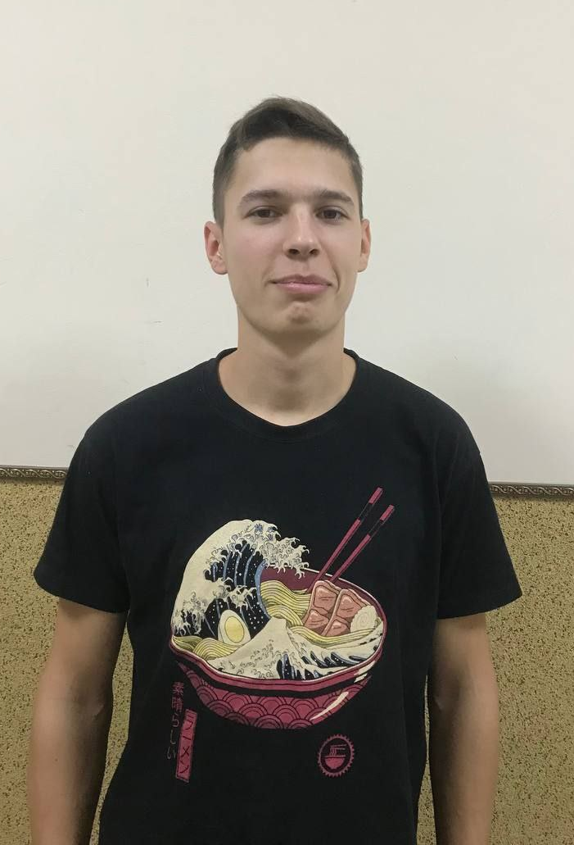
My name is Oleh Driomov, and I’m 19. I am from Kramatorsk, Donetsk region. My parents are Christians. My father is involved in youth and prayer ministries, and my mother is a Sunday school teacher. I have two brothers and one sister. My family is separated due to the war. We sent my mom and younger siblings to Sweden, but my father, my brother and I were displaced to Western Ukraine because Kramatorsk is very close to the frontline.
I’ve visited church since my childhood, but my heart didn’t belong to God. I had some addictions that were spoiling my life. One day, after confessing them to my mother, we went to our pastor, and I repented there and accepted Jesus into my life. God set me free and started changing my character.
In my church, I help with the sound system and sometimes preach. I pray that God would reveal His plan for my life and future ministry to me, so I could follow it.
When the war started, I was forced to leave my home and run away from bombs. I ended up living in a Pentecostal church near Lviv. There I’ve heard about Lviv Theological Seminary. I came to the seminary to know God more. This is my second year at LTS, and I see great changes in my life. I started to read the Bible more systematically and understand it better. My self-discipline has improved a lot. I thank God for this opportunity to be here.

